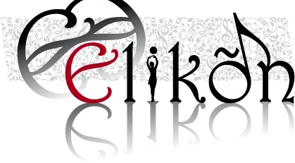

Permission for the use of photographs and videos of our pupils

I hereby give the permission to the ELIKON cultural association to take and use photographs videos and recordings of my child(ren), during the Piandelagotti art theatre and music summer courses, for the purposes of promoting in any publicity form (web, website, facebook, printed material….ecc..) the activity of the ELIKON association.

Child’s full name_____________________________________________________

Parent’s full name____________________________________________________

DATE: SIGNATURE:

__________________ ____________________

